1. to check even or odd Write a c pogram?

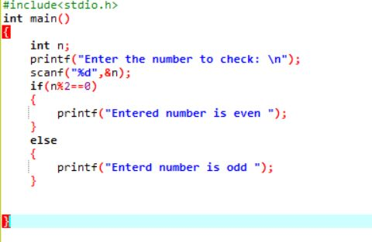

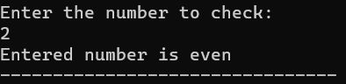

1. C program to find sum of n numbers?

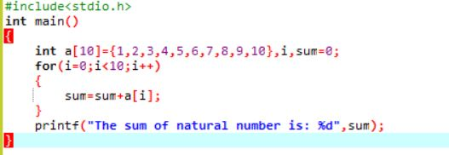

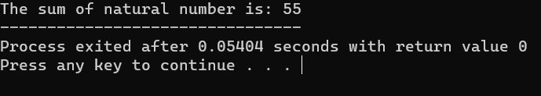

1. C program to find sum of even numbers?

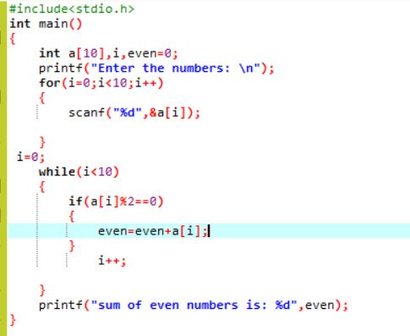

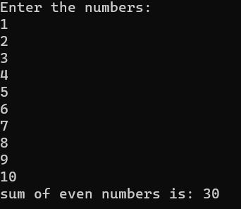

1. C pogram to find reverse of a number?

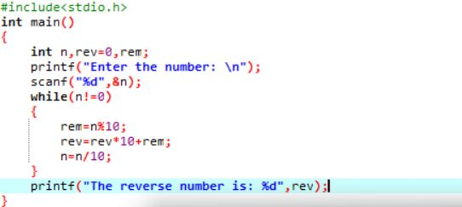

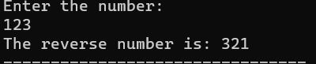

1. C pogram to check whather given number is pallindrome or not?

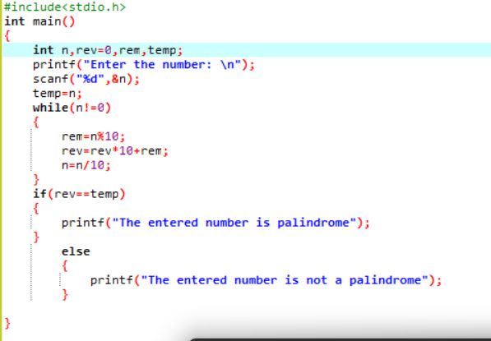

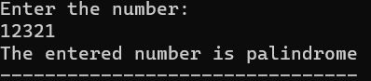

1. C pogram to check wheather armstrong number or not?

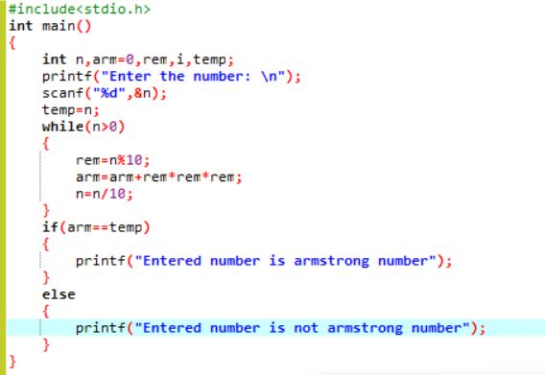

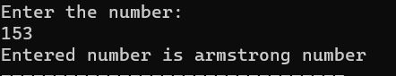

6.c pogram to find factorial of number without recursion?

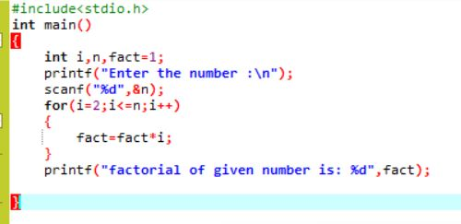

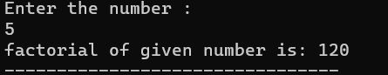

7. c pogram to find factorial of number with recursion?

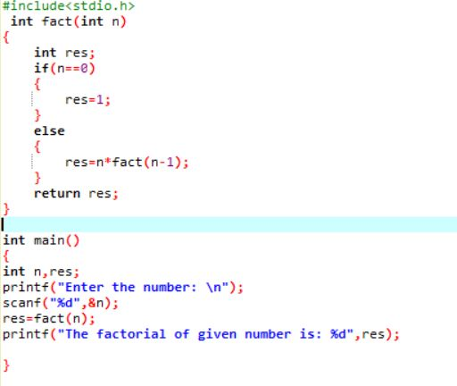



9. fibonic series without recursion?

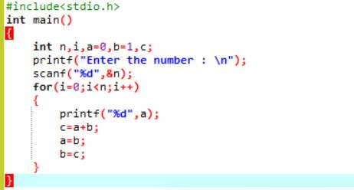

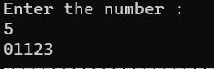

10. fibonic series with recursion?

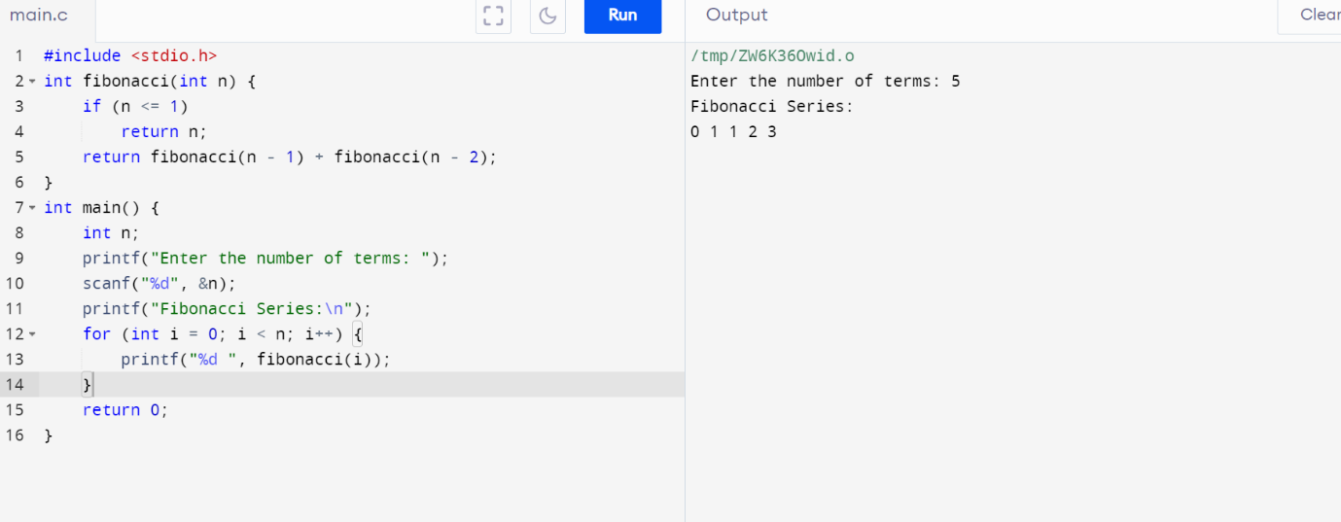



11. c program to search an element in array using linear search?

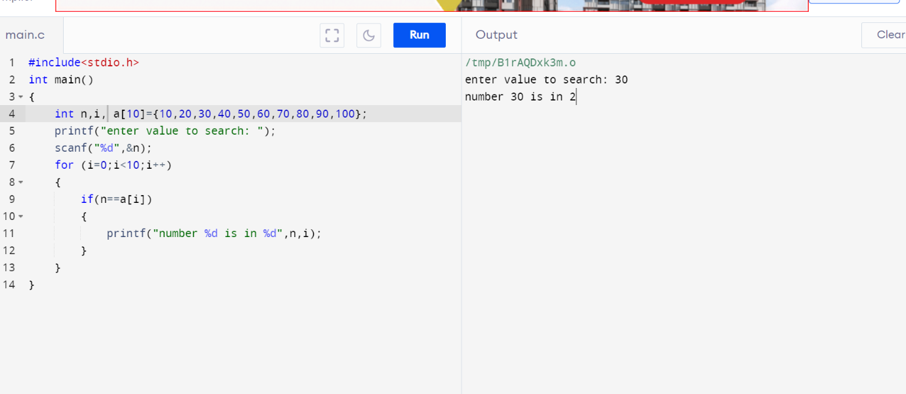

12. c program to search an element in array using binary search?

